Physical Science
Course Syllabus
2017-2018 School Year
Instructor: Kristin Nicholson
Room #: 14-036 I Wing
Phone: (863)499-2655
Email: Kristin.Nicholson@polk-fl.net (Best way to contact me)

- Description
Lessons in this course are derived from the study of chemistry and physics in the natural world. Topics covered in this course range from atomic theory and the division of matter into subatomic particles to Newton's laws of motion. By the course's end, you'll be able to recognize how these concepts relate to chemical reaction rates, phase changes, the generation of electrical power and more. Laboratory investigations that include the use of scientific inquiry, research, measurement, problem solving, laboratory apparatus and technologies, experimental procedures, and safety procedures are an integral part of this course.

- Organization
This is a lecture-lab course in which topics are presented by the instructor, labs and lab reports are explained, and then, are completed by students both during class period and outside of class. Pre-lab quizzes will be given before each lab to ensure full understanding of the content within the lab. Subject matter quizzes will be given throughout each unit, and there is a comprehensive mid-term and final exam. All assignments MUST have your name, date, and class period included, in order to be graded.

- Course Objectives
- Develop and improve the ability to analyze contextual information within a given text by application.
- Develop and improve collaborative skills such as, listening, speaking and debating, by working with others to reach a common goal.
- Develop and improve basic modern technological skills.
- Apply skills learned to the world in which we live in in order to make more sense of obtained knowledge.

- Course Topics

- The Nature of Science
- Mechanics
- Energy, Work, and Power
- Heat Transfer
- Kinetic Theory
- Properties of Matter
- Grading scale
100-90 A
89-80 B
79-70 C
69-60 D
> 59 F

- Waves
- Electricity
- Atomic Theory
- Periodicity and Bonding
- Reactions
- Biogeochemical Cycles

Tests/Labs 50pts
Quizzes 25pts
Classwork/Homework 20pts
Participation 20pts

- Text and Required Supplies
Book: Prentice Hall-Physical Science: Concepts in Action with Earth and Space Science
Supplies needed for this class:

    - 1 3-ring binder (at least 1” in size) FOR SCIENCE USE ONLY!(required)
    - 1 3 prong paper folder with pockets
    - 2014-15 Planner
    - Flash Drive (Any size will do)
    - Scientific Calculator
    - Pens and pencils (required)
    - Dividers for your binder(required)

*DO NOT SHOW UP TO MY CLASS UNPREPARED!!! YOU MUST ALWAYS HAVE SOMETHING TO WRITE ON AND SOMETHING TO WRITE WITH. SHOWING UP TO MY CLASS UNPREPARED WILL RESULT IN A ZERO FOR THAT DAY’S PARTICIPATION.

- Attendance Policy and Late Assignments
If you are absent, unexcused or excused, YOU ARE RESPONSIBLE for asking me what you missed, as well as, making it up. If you are absent on the day of a test or quiz, you may only make up it up if your absence was EXCUSED. If you miss a lab, you must come see me in order to schedule an appropriate day and time that you can make it up. Once you return, you have 3 days to make up a test or quiz before it becomes a zero in the grade book. For homework, you have 1 day to make it up before it becomes a zero. If you are going to be absent for an extended amount of time, please let me know ASAP so you can be given work in order to avoid falling too far behind.
It is the schools policy that if you miss more than ten(10) days you will be required to take and pass the end of semester exam in order to receive credit for the course. This applies to all classes!
I DO NOT ACCEPT LATE ASSIGNMENTS!! When I give you a due date, there is NO negotiating. If you try and turn in a late assignment I will not grade it.
- Code of conduct (KHS Policies within the student handbook also apply)
- Come to class on time and be prepared!!
- NO SLEEPING!! NO EXCEPTIONS!!
- Respect each other, your teacher, and yourselves.
- Bullying, or any other form of harassment, will not be tolerated.
- When classwork is assigned it is to be done in the classroom, not saved to complete at home.
- Class lab time is expected to be spent in lab work. Lab time is not free time. Work at home will be required in addition to work during lab times (work at home should not substitute for work during lab periods). **Appropriate lab attire is required. Failure to comply will result in a ZERO for that lab.**
- There will be no food or drink of any kind in the class, with the exception of water that is in a capped bottle.
- Stay in your seat until the bell rings!
Consequences:
1st- Verbal Warning
2nd- Call to parent and/or removal from classroom
3rd- Referral

- Cell Phones
Cell phones are not to be seen during class time. Occasionally, there will be times that I will allow and encourage the use of your phone for educational purposes, otherwise it is to be on silent and out of sight. If I see or hear your phone during class time without given permission, you will receive ONE warning. After that, it will be subject to confiscation by an administrator, where your parent/guardian will have to pick it up.

Ms. Nicholson created Phys. Science on Remind.
Follow these steps to join!
- Download the Remind app. It’s free!
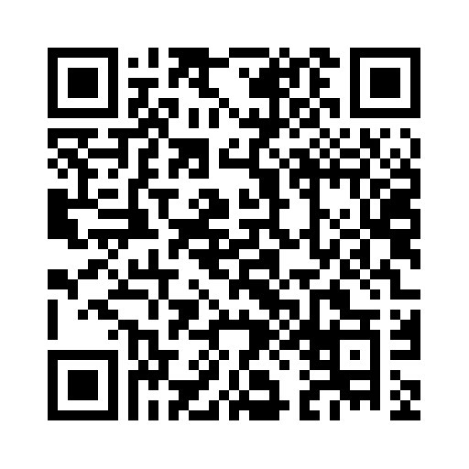
- Enter the class code
@f2159
Or visit this link:  www.remind.com/join/f2159 | 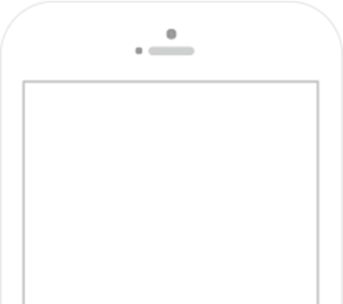  Join via SMS!  Enter this number  (386) 742-6964  with this message  @f2159
What’s Remind?
Remind is a simple way for you to stay informed and up-to-date with what’s happening in your class. By joining your teacher’s class on Remind, you’re choosing to receive class messages via push notifications, SMS, or email. Don’t worry, your phone number will not be shared with the teacher or anyone else in the class.

